**Project Design**

**Features**

Here is a list of features included in the Web-App:

1. Registration Module
2. Login/Logout Module
3. Dashboard (Landing Page)
4. User Input Module
5. Document Upload Module
6. Fetch Data from database
7. Download Document

**Structure**

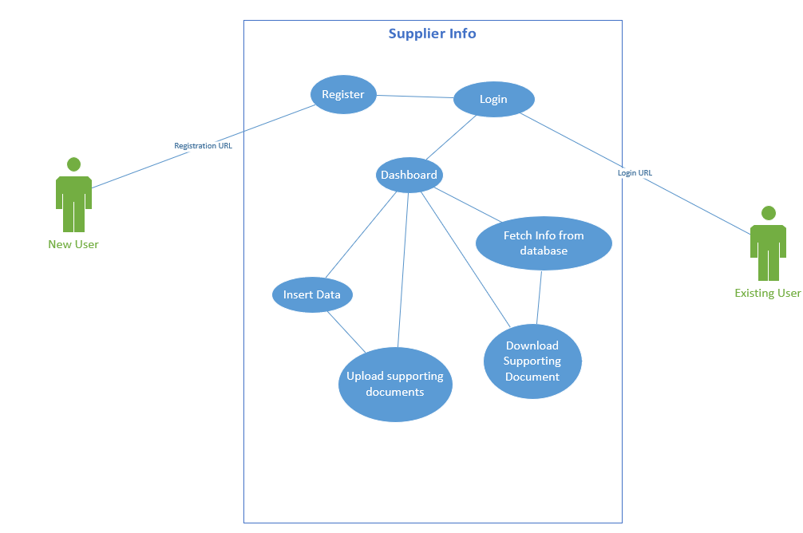The following is a Use Case Diagram that illustrates the structure of the Web-App:

Figure 1- Use Case Scenario

The diagram above indicates that there are two types of users which are:

1. The New User
2. The Existing User

The Use Cases are as follows:

1. **Registration**: The registration is specifically for new users who do not have login credentials, so a new user is given a URL for the registration.
2. **Login**: Upon successful registration the user will be redirected to the login page. As for the existing users they can just go directly to the login URL that will be provided
3. **Dashboard**: The dashboard links all the rest of the features together
4. **Insert Data**: This is where the user goes to enter information about the suppliers.
5. **Upload supporting Documents**: This is and extension of the insert data feature
6. **Fetch Info from the Database**: Retrieves information from the database and displays it to the end user
7. **Download Supporting Documents**: This feature allows users to download documents that have been uploaded by any user.
8. **Search**: Allow users to search for a particular entry

**User Interface & Experience (UI/UX)**

The following is a set of wireframes for the layout of the Web-App:

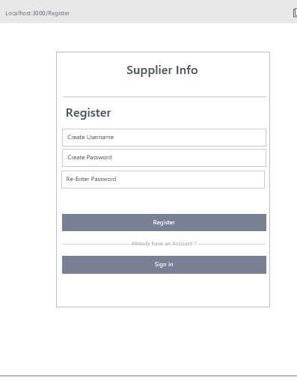Registration Module:

Figure Registration Form

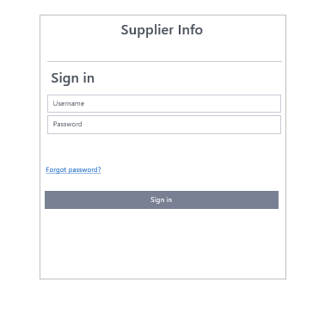Login Module:

Figure Login Page

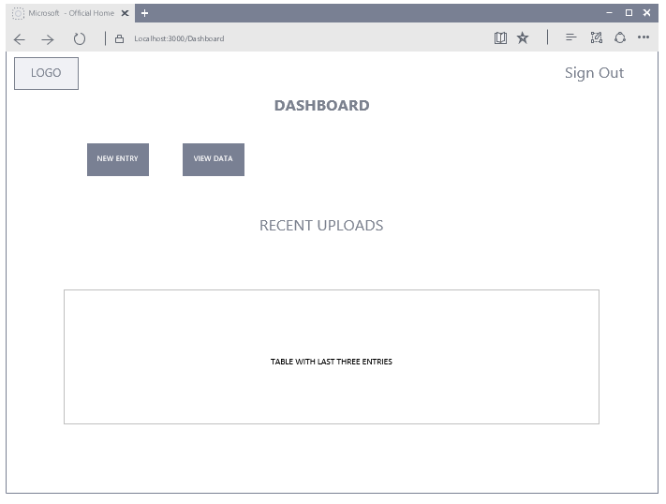Dashboard:

Figure Dashboard

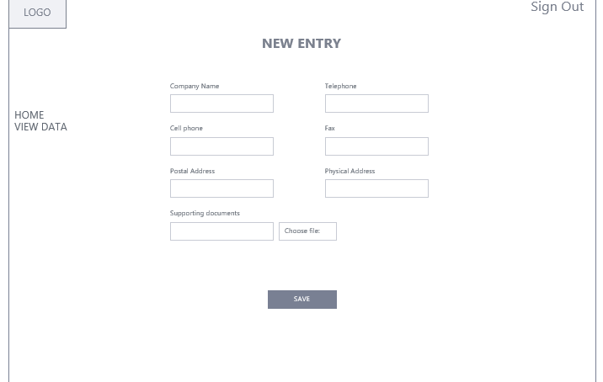New Entry:

Figure New Entry

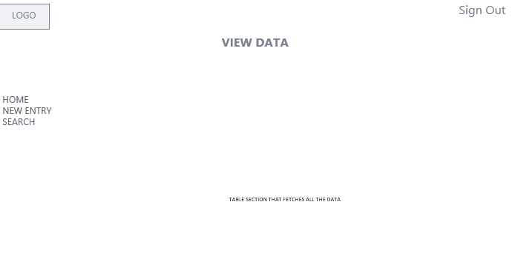

Figure View

View Data:

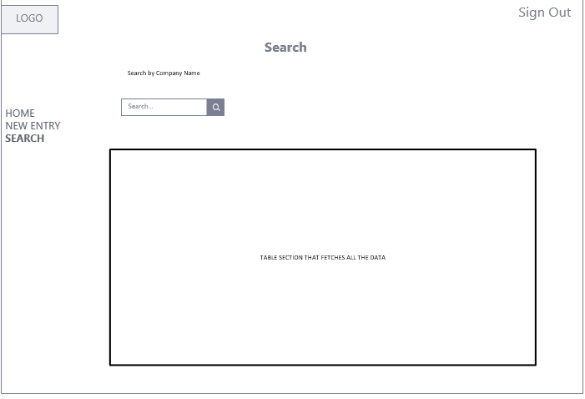

Search:

Figure Search